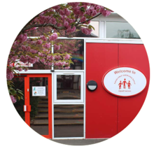
Summer 2 2024 Newsletter 7
Fairisle Infant and Nursery Schools 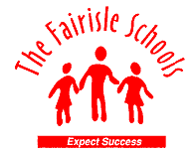children’s newsletter

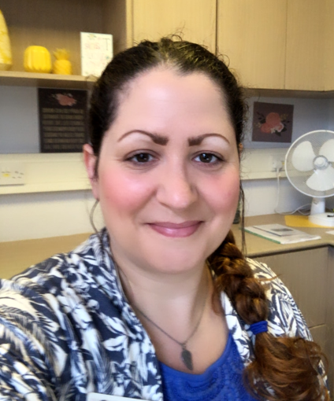
A message from the Headteacher
As we approach the end of this academic year we sadly need to say some goodbyes…
We will be losing two of our fantastic home-grown teachers Lucy Sevier and Gemma Orman. They started with us as ECT’s in 2021.They are pursuing new teaching roles as part of their career progression in schools in Dorset and Southampton. We will miss them dearly but wish them well in their new adventures.

Noemia Sousa has started her maternity leave - we wish her all the best and can't wait to meet her little bundle of joy!

Louise Bagg left us on 5th July to join the NHS. She has been a loyal member of our team and has been with us for nearly two decades. She came here as a child herself and both her children came to Fairisle - we wish her all the best in her new role and say an enormous thank you for her hard work.

Sarah Coulson (TA) and Jessica Fear (Breakfast/After School Club) will be leaving us to pursue new roles.
I am sure you will join me in saying a colossal thank you to all our leavers for their dedication, kindness and support to all our children, families and staff. Your will all be missed!
We wish them the best of luck!

Miss Owens, Headteacher

Welcomes
In September, we welcome to our Fairisle Family…
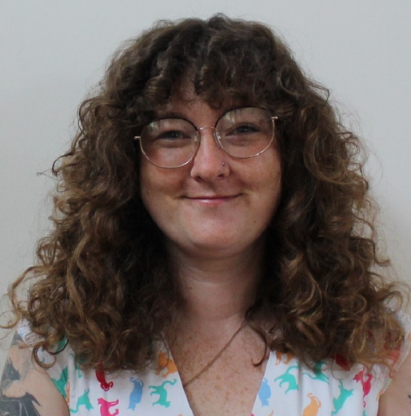 | 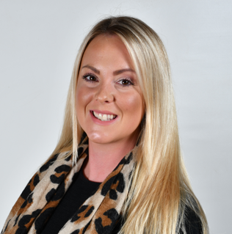 | 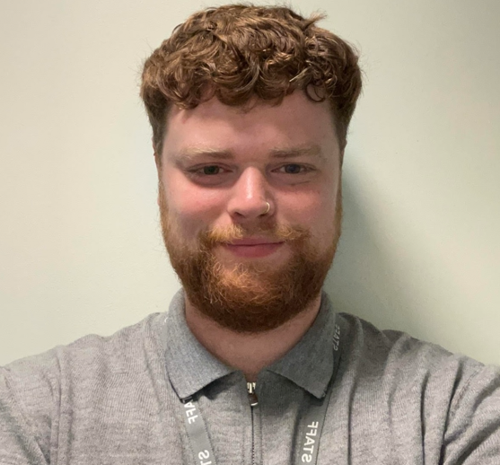 | 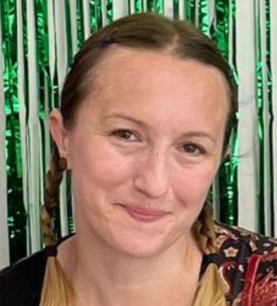 | 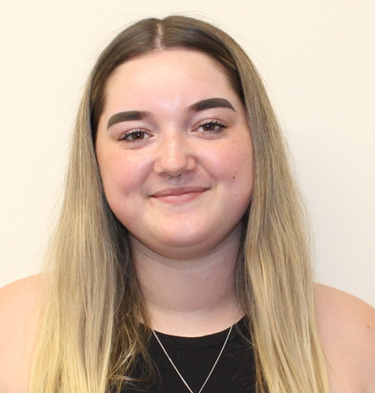
Mrs Danielle Tuncan (Mrs T) | Miss Abbey Ramsdale | Mr Callum Carter | Mrs Izabela Szwarkowska | Miss Chelsie

Rainbow Room
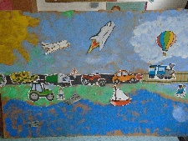
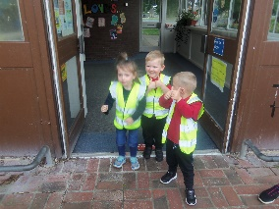
We were very excited in Rainbow Nursery to visit Lordshill Library this half term. Our grown-ups came too. We had lots of fun listening to stories, joining in with songs, rhymes and creative activities. We have all enjoyed the lovely sunny weather in our garden. We have explored the themes of transport, holidays and keeping safe in the sun as well as learning about healthy eating and lifestyles.

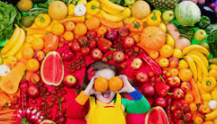
Sunshine Room
Sunshine has had a fantastic summer term! We have enjoyed lots of time in the garden doing our learning outdoors, including reading new books, writing our names, number games and climbing. Healthy Fun Week was a success where we took part in making fruit wands and tasting different fruits. We spent time in the ‘big school’ hall exploring the hula hoops, and practised calming strategies to support our mental health. Lots of our children will be moving up to Year R in September. We wish them all the best and do hope that they come back and say hello to us in the new school year! We say ‘see you soon’ to the children who will be returning to Sunshine in September and look forward to even more memories that we will be able to create! We wish you all a safe and happy summer!
Year R
Year R have been learning all about transitions and some of the similarities and differences between Year R and Year One. We have also been talking about some of the feelings and emotions that we have in relation to this new step in our lives. Here is what some of the children in Year R are looking forward to in Year One.
Theo from Squirrels says, I am looking forward to going out for play with Year Two, the new writing in Year One and going to more assemblies'.
Heaven from Foxes says, 'I am looking forward to the new learning especially Maths and counting. I can't wait to use the Red Area in Leopards Class as it looks like so much fun. The trip in Year One sounds like a lot of fun too. I bet I will get lots of stickers in Year One.'
JJ from hedgehogs says, 'I'm going to be aTtiger. Mrs Du Toit loves singing just like me. My favourite song is Build Up. I can't wait to see what reading books they have and to use the laptops.'

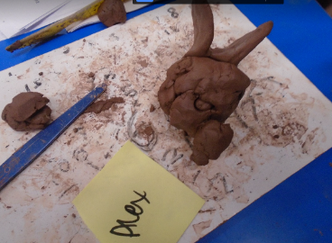
Year 1
In Year 1 this term we have been exploring lots of different topics and it has been lovely to see their creativity this term shine through! In Art we have been working with clay and making sculptures of mythical creatures, in Geography we have been learning about China and how it compares to England. The children have been finding out amazing facts at home and bringing these in to share with the class! In Maths we have been learning how to find halves and quarters of both shapes and numbers. In Writing we have been looking at Sir Charlie Stinky Socks and the Great Adventure and using this to inspire us to create our own Wiggly Woos! In Science we have looked at plants and trees and how important each part of the plant is and their function.
Sophia (Lions) – I liked doing everything because it’s just so fun and its super and we keep ourselves safe so we know what to do.
Aria (Lions) – I enjoyed making the clay in Art because I got to practice how to make our sculptures.
Abigail (Tigers) – I liked Sir Charlie where he gave the dragon some water because the dragon went ‘ahhhh’ because he liked the water.


Year 2
Year 2s time at the school has now sadly come to an end. They have been a fantastic year group and we
have got so many wonderful memories that we have shared together. From being baked in the sun at Marwell, to being soaked through at Hillers it has all been amazing.
Isla- I was with Miss McGovern and Miss Marris at Hilliers and we got drenched.
Rosalie- My socks were soaking when I got home!
There has been so much laughter, joy and tears…especially during the last few weeks!
Harrison- All the memories we have had here together through the years are so much fun.
Theo- I loved Pirate Day because we got to dress up as a pirate and we called Miss Orman Captain Orman!!
Maya B- SeaCity Museum was great because we got to see the Titanic and see what happened. It was fun because some of us got to dress up as Captain Smith.
Thank you to all the parents and children for a fabulous year…we will miss you all a great deal. Make sure you pop back to say hi!

